**6. ReactJS-HOL**

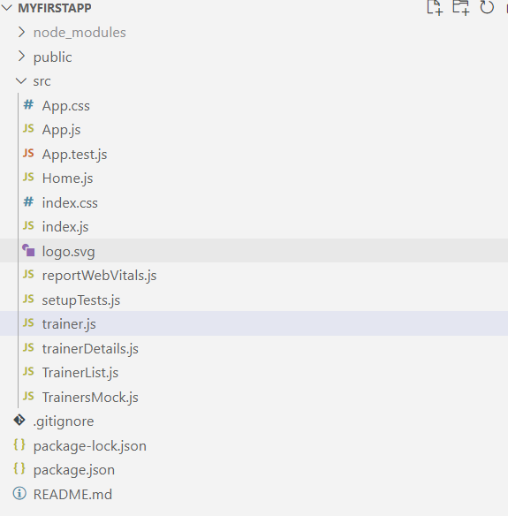

**trainer.js**

class Trainer {

    constructor(trainerId, name, phone, email, technology, skills) {

      this.trainerId = trainerId;

      this.name = name;

      this.phone = phone;

      this.email = email;

      this.technology = technology;

      this.skills = skills;

    }

  }

  export default Trainer;

**TrainersMock.js**

import Trainer from './trainer';

const trainers = [

  new Trainer(1, "John Doe", "1234567890", "john@example.com", "React", ["JavaScript", "React", "Redux"]),

  new Trainer(2, "Jane Smith", "9876543210", "jane@example.com", "Angular", ["TypeScript", "Angular", "RxJS"]),

  new Trainer(3, "Alice Johnson", "5556667777", "alice@example.com", "Vue", ["Vue", "Vuex", "JS"])

];

export default trainers;

**TrainerList.js**

import React from 'react';

import { Link } from 'react-router-dom';

const TrainerList = ({ trainers }) => {

  return (

    <div>

      <h2>Trainers List</h2>

      <ul>

        {trainers.map(trainer => (

          <li key={trainer.trainerId}>

            <Link to={`/trainer/${trainer.trainerId}`}>{trainer.name}</Link>

          </li>

        ))}

      </ul>

    </div>

  );

};

export default TrainerList;

**Home.js**

import React from 'react';

const Home = () => (

  <div>

    <h1>Welcome to the TrainersApp</h1>

    <p>This app helps you browse Cognizant trainers and their expertise.</p>

  </div>

);

export default Home;

**trainerDetails.js**

import React from 'react';

import { useParams } from 'react-router-dom';

import trainers from './TrainersMock';

const TrainerDetail = () => {

  const { id } = useParams();

  const trainer = trainers.find(t => t.trainerId === parseInt(id));

  if (!trainer) return <p>Trainer not found!</p>;

  return (

    <div>

      <h2>{trainer.name}</h2>

      <p><strong>Email:</strong> {trainer.email}</p>

      <p><strong>Phone:</strong> {trainer.phone}</p>

      <p><strong>Technology:</strong> {trainer.technology}</p>

      <p><strong>Skills:</strong> {trainer.skills.join(', ')}</p>

    </div>

  );

};

export default TrainerDetail;

**App.js**

import React from 'react';

import { BrowserRouter as Router, Routes, Route, Link } from 'react-router-dom';

import Home from './Home';

import TrainerList from './TrainerList';

import TrainerDetail from './trainerDetails';

import trainers from './TrainersMock';

function App() {

  return (

    <Router>

      <div>

        <nav style={{ padding: '10px', backgroundColor: '#f0f0f0' }}>

          <Link to="/" style={{ marginRight: '15px' }}>Home</Link>

          <Link to="/trainers">Trainers</Link>

        </nav>

        <div style={{ padding: '20px' }}>

          <Routes>

            <Route path="/" element={<Home />} />

            <Route path="/trainers" element={<TrainerList trainers={trainers} />} />

            <Route path="/trainer/:id" element={<TrainerDetail />} />

          </Routes>

        </div>

      </div>

    </Router>

  );

}

export default App;

OUTPUT

